Assignment: Convolutional Neural Networks
Objective
The objective of this lab was to understand the working of convolutional neural networks by implementing convolution and pooling operations from scratch using NumPy. Different image kernels were applied to observe their effects on images. We also studied the impact of stride, padding, ReLU activation, and pooling operations on feature extraction.

Part 1: Implementing Convolution and Pooling from Scratch
1. Convolution Implementation
A 2D convolution function was implemented using NumPy. The implementation supports different stride values and padding. During convolution, the kernel slides across the image and computes the weighted sum of the overlapping pixels.

2. Max Pooling Implementation
A Max Pooling function was implemented to reduce the spatial dimensions of the feature map. The maximum value within each pooling window is selected and stored in the output feature map.

3. Average Pooling Implementation
An Average Pooling function was implemented where the average value of all pixels inside the pooling window is calculated and stored in the output feature map.

Experiment 1: Applying Different Kernels
Identity Kernel
The output image remained almost identical to the original image. This kernel preserves the original pixel values.
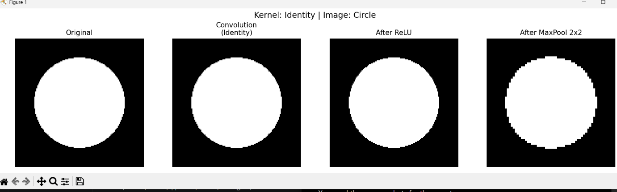
Laplacian Kernel
The Laplacian kernel highlighted the boundaries of the object and produced strong responses near edges.
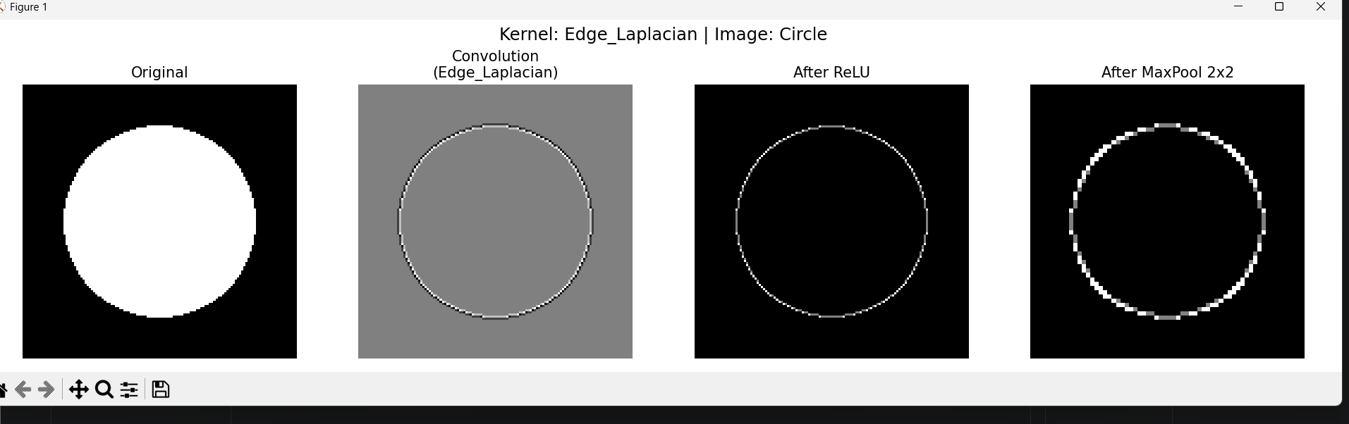

Sobel Horizontal Kernel
This kernel emphasized horizontal intensity changes and detected vertical edges in the image. 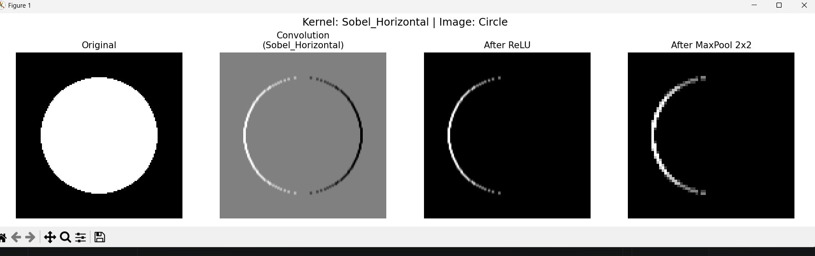

Sobel Vertical Kernel
This kernel highlighted vertical intensity changes and detected horizontal edges. 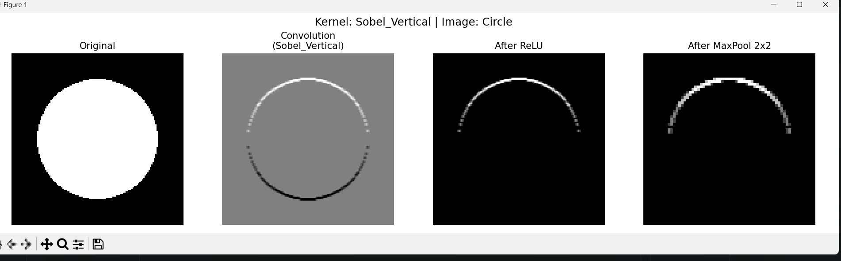

Sharpen Kernel
The sharpen kernel enhanced the edges and made the image appear clearer and more detailed. 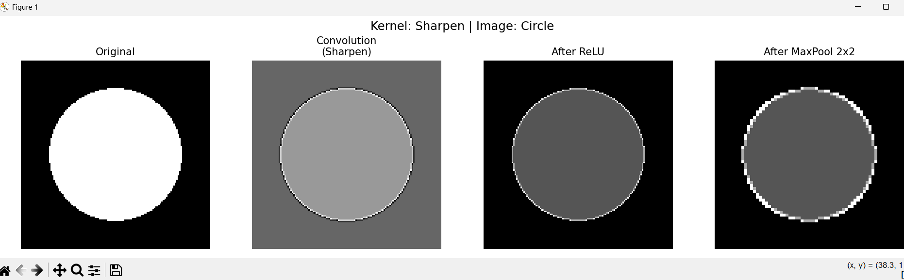

Gaussian Blur Kernel
The image became smoother and noisy details were reduced due to averaging of neighboring pixels. 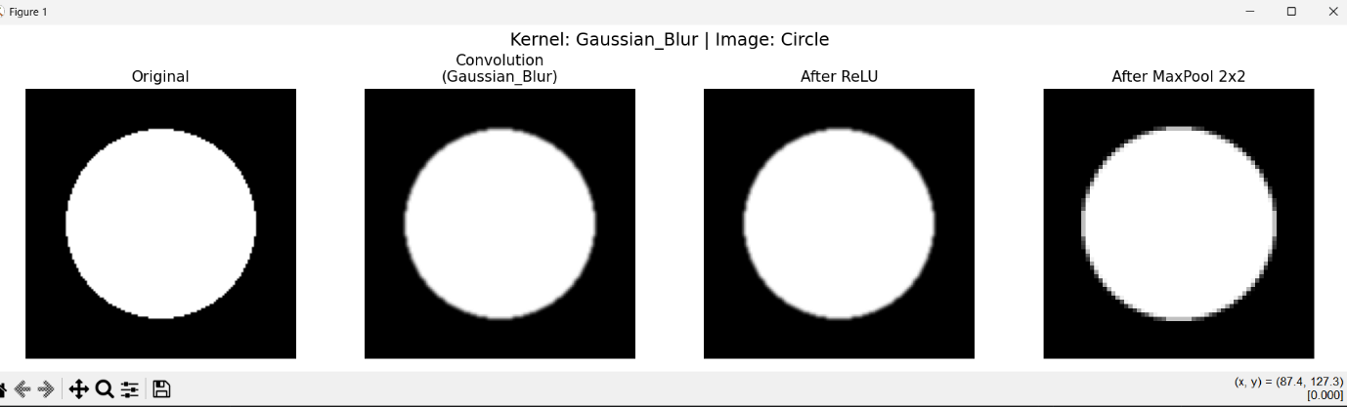

Emboss Kernel
The emboss kernel created a 3D-like appearance by emphasizing directional intensity variations. 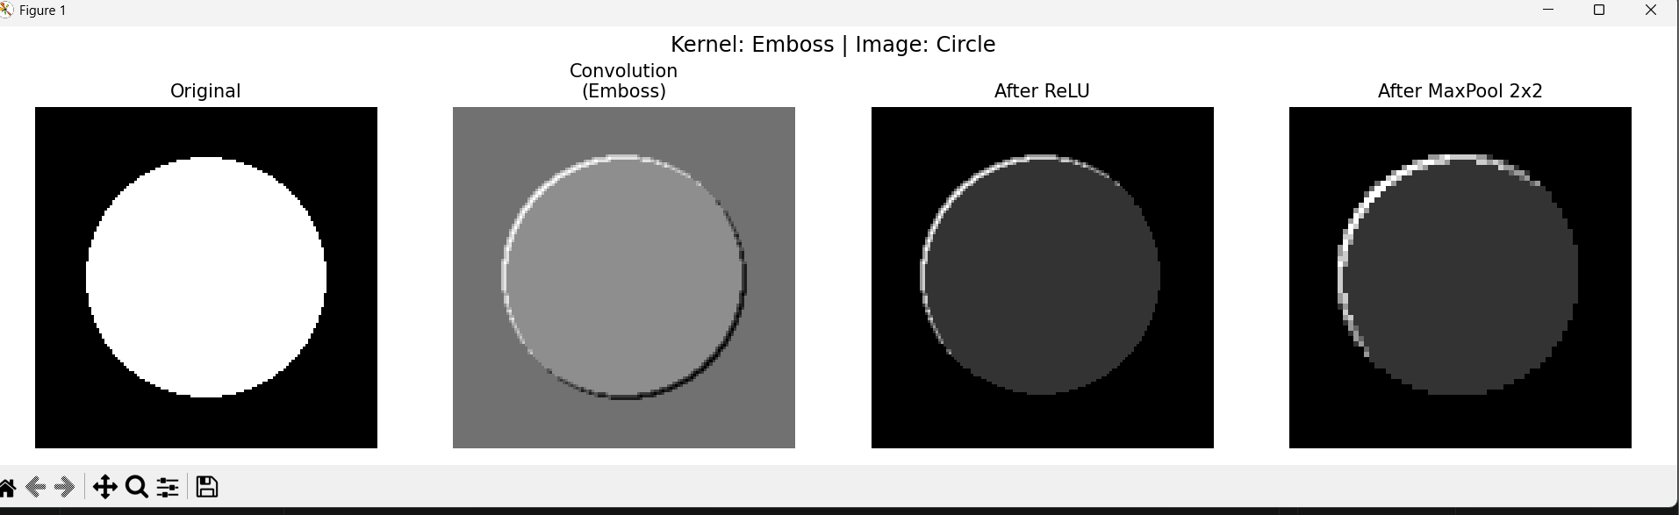

Experiment 2: Effect of Stride and Padding
Observation
- Increasing stride reduced the size of the output feature map.
- Higher stride values resulted in faster computation but loss of fine details.
- Padding preserved border information and maintained larger output dimensions.
- Without padding, the output image became smaller after convolution. 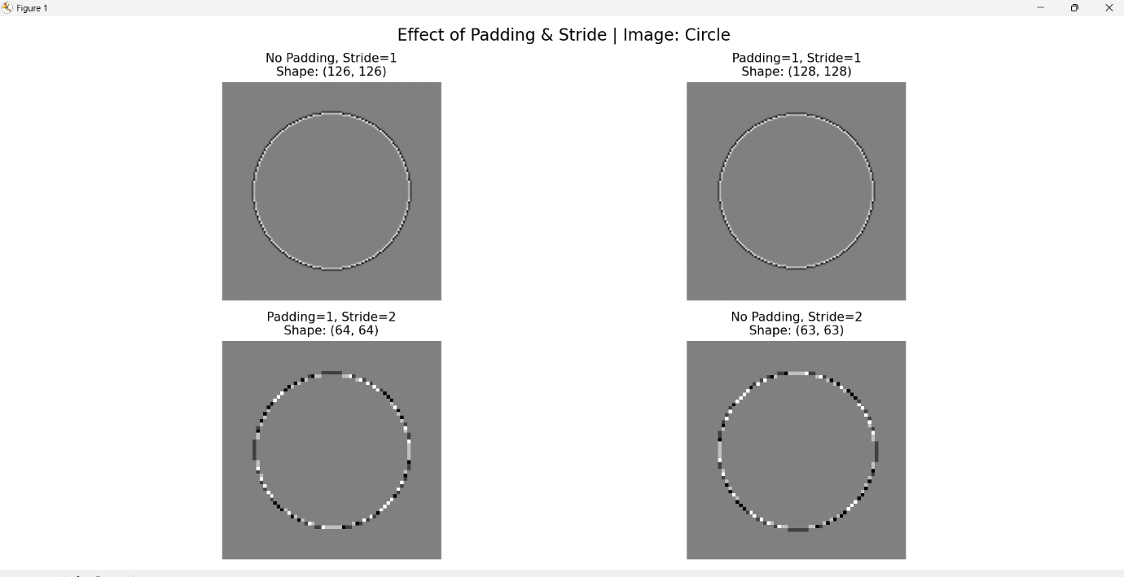

Experiment 3: Max Pooling vs Average Pooling
Observation
- Max Pooling retained the strongest features and edge information.
- Average Pooling produced a smoother output by averaging neighboring values.
- Max Pooling preserved important structures more effectively than Average Pooling. 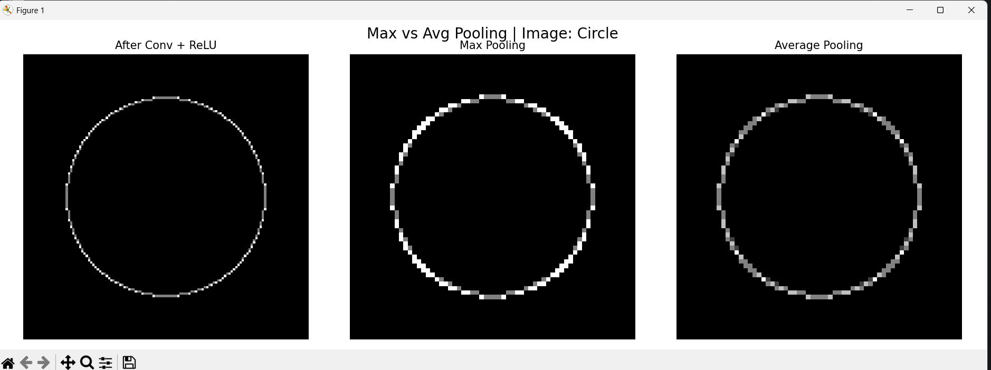

Analysis Questions
1. Why does the Laplacian kernel highlight edges?
The Laplacian kernel computes second-order intensity differences. Since pixel values change rapidly near edges, the kernel produces large responses at those locations, thereby highlighting edges.

2. What is the effect of increasing stride in convolution and pooling?
Increasing stride reduces the output feature map size and computational cost. However, some image information may be skipped, resulting in loss of details.

3. How does max pooling help achieve translation invariance?
Max pooling selects the strongest activation within a local region. Small shifts in the position of an object often do not change the maximum value significantly, making the network less sensitive to minor translations.

4. What happens if padding is removed when using large kernels?
Without padding, the output feature map shrinks after each convolution. Information near image boundaries is lost, and repeated convolutions can significantly reduce the spatial dimensions.

Conclusion
In this lab, convolution and pooling operations were implemented from scratch using NumPy. Different kernels were applied to understand feature extraction. The experiments demonstrated the effects of stride, padding, ReLU activation, and pooling methods. The lab provided practical insight into the fundamental building blocks of convolutional neural networks.

Part 2: Training Deep CNNs on CIFAR-10
Objective
The objective of this part was to study how different CNN architectures affect image classification performance on the CIFAR-10 dataset. We compared a baseline CNN, a CNN with Batch Normalization, a deeper CNN, and a ResNet-style network with residual connections.
Dataset and Preprocessing
The CIFAR-10 dataset consists of 60,000 RGB images of size 32×32 belonging to 10 classes: airplane, automobile, bird, cat, deer, dog, frog, horse, ship, and truck.
The following preprocessing techniques were applied:
- Random Cropping
- Random Horizontal Flipping
- Normalization
These transformations improve generalization and help the model learn robust features.
Model 1: Baseline CNN
The baseline CNN consisted of two convolutional layers followed by ReLU activation and Max Pooling layers. Fully connected layers were used for final classification.
Observation
The model learned meaningful image features and achieved a validation accuracy of 75.58%. The training and validation losses decreased steadily throughout training. 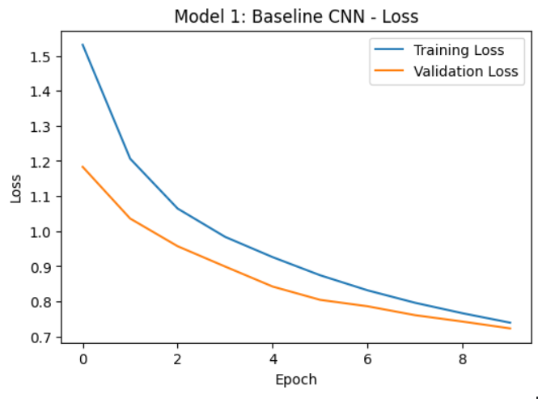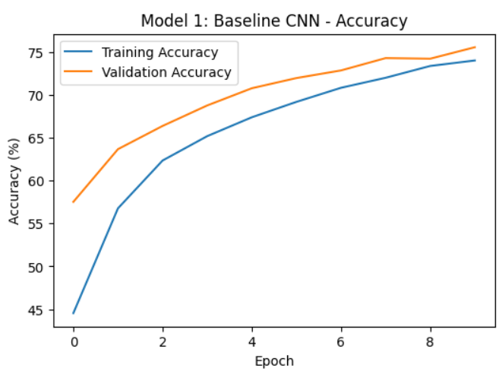

Model 2: CNN with Batch Normalization
Batch Normalization layers were added after each convolutional layer to stabilize training and normalize activations.
Observation
The model achieved a validation accuracy of 74.65%. Although Batch Normalization generally improves convergence, in this experiment the performance was similar to the baseline model. 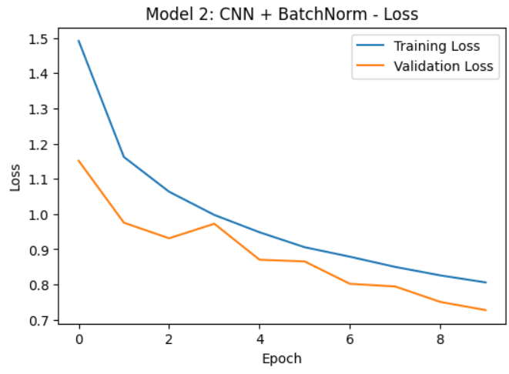
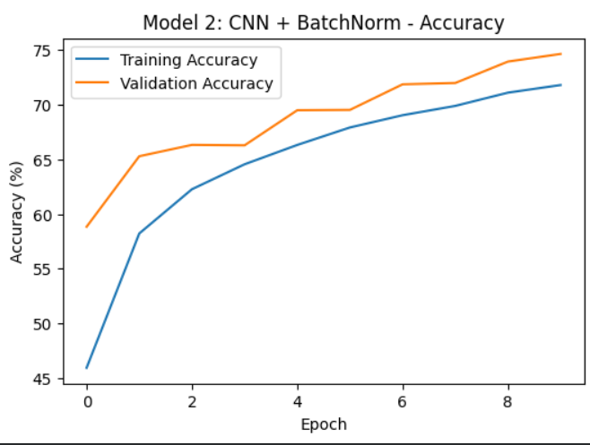

Model 3: Deep CNN
A deeper architecture consisting of multiple convolutional layers was implemented to increase the representation power of the network.
Observation
The deeper network achieved a validation accuracy of 82.10%. The additional layers enabled the model to learn more complex hierarchical features, leading to a significant improvement in performance.
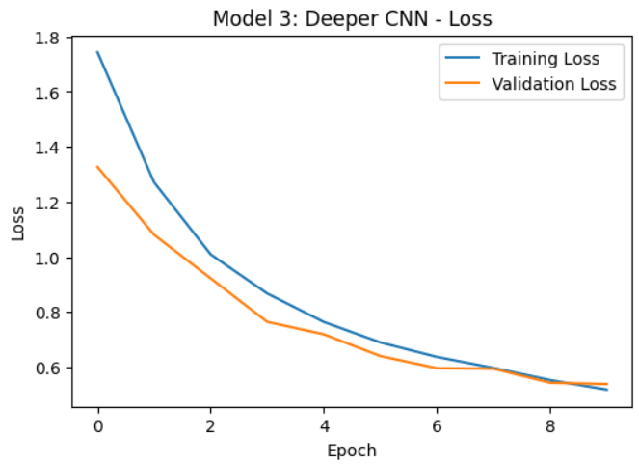
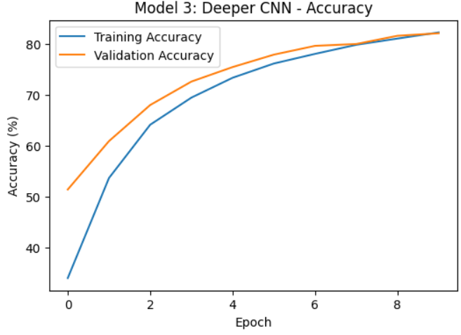

Model 4: Small ResNet
Residual blocks with skip connections were introduced to improve gradient flow and enable efficient training of deeper networks.

Observation
The Small ResNet achieved the highest validation accuracy of 85.20%. The skip connections reduced optimization difficulties and allowed the network to learn more effectively. 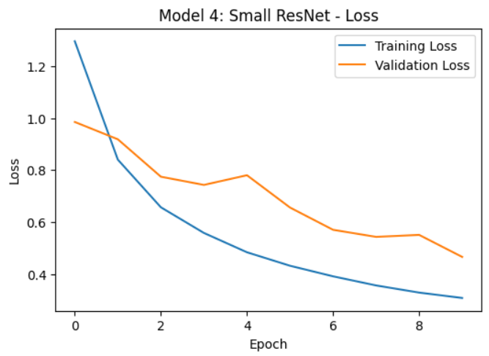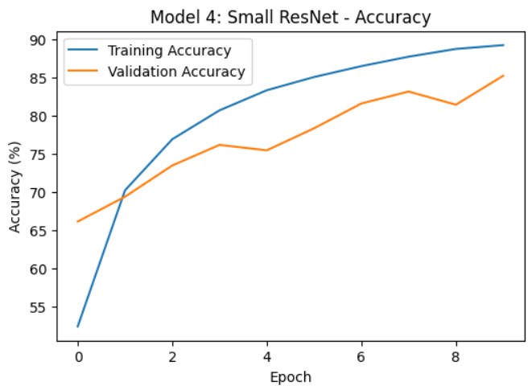

Final Results
Model | Validation Accuracy
Baseline CNN | 75.58%
BatchNorm CNN | 74.65%
Deep CNN | 82.10%
Small ResNet | 85.20%
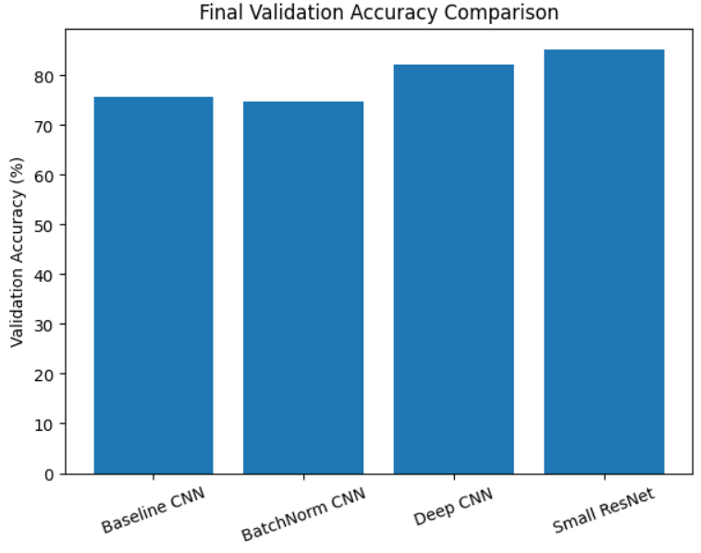
Analysis Questions
1. How much does Batch Normalization help?
Batch Normalization stabilizes training by normalizing activations within each mini batch. It often accelerates convergence and improves training stability. In this experiment, the performance was like the baseline model, indicating that the effect of Batch Normalization depends on architecture and training conditions.
2. Why does a plain deeper network sometimes perform worse?
As network depth increases, optimization becomes more difficult due to vanishing gradients and degradation problems. Although deeper networks have greater representational capacity, they may become harder to train effectively.
3. How do skip connections help in training deeper networks?
Skip connections provide a direct path for gradients to flow through the network during backpropagation. This reduces degradation issues and improves optimization. The superior performance of the Small ResNet demonstrates the effectiveness of residual learning.
Conclusion
This experiment demonstrated the importance of architecture design in convolutional neural networks. While the baseline CNN achieved satisfactory performance, deeper architectures extracted more meaningful features and achieved higher accuracy. The Small ResNet obtained the best performance with a validation accuracy of 85.20%, highlighting the benefits of residual connections for deep neural networks.

